C:\Users\ankit\Documents\Sementic WEB\django\dm>python manage.py runserver

Movie Actors:

match(y:owl__Class)-[:rdfs__subClassOf]->(x:owl__Class{rdfs__label:"Actors"}) return y.rdfs__label as Actors

Ayushmann Khuranna

Radhika Apte

Sonam Kapoor

Tabu

Sanjay Malhotra

Akshay Kumar

Neena Gupta

Dolly Ahluwalia

Annu Kapoor

Directors:

match(x:ns1__Director) return x as Directors

Amit Sharma

Sriram Raghavan

R.Balki

Shoojit Sircar

Movie:

match(x:ns1__Movie) return x as Movies

Badhaai Ho

Vicky Donor

Andhadhun

Padman

Predicates

match(x:owl__ObjectProperty) return x as Predicates

|  |  |
| --- | --- |
| hasRating | "http://www.iiitb.ac.in/MovieOntology#hasRating" |
| hasGenre | "http://www.iiitb.ac.in/MovieOntology#hasGenre" |
| Acted_In | "http://www.iiitb.ac.in/MovieOntology#Acted_In" |
| isDirectorOf | "http://www.iiitb.ac.in/MovieOntology#isDirectorOf" |

Query 0

call semantics.importRDF("file:///C:/users/ankit/Movie-Ontology.owl","RDF/XML",{})

Query 1

Match(x:owl__ObjectProperty)-[:rdfs__domain]->(y:owl__Class),(y:owl__Class)-[:rdfs__subClassOf]-(z),(x:owl__ObjectProperty)-[:rdfs__range]-(a),(b:owl__Class)-[rdfs__subClassOf]->(a) where x.rdfs__label="Has Director" return x,y,z,a,b

Query 2

Match(pred:owl__ObjectProperty)-[:rdfs__domain]->(sub:owl__Class),(sub:owl__Class)-[:rdfs__subClassOf]-(sub_name),(pred:owl__ObjectProperty)-[:rdfs__range]-(obj),(obj_name:owl__Class)-[rdfs__subClassOf]->(obj) where pred.rdfs__label="Has Actor" and obj_name.rdfs__label="Tabu" return pred,sub,sub_name,obj,obj_name

Query 2

Match(pred:owl__ObjectProperty)-[:rdfs__domain]->(sub:owl__Class),(sub:owl__Class)-[:rdfs__subClassOf]-(sub_name),(pred:owl__ObjectProperty)-[:rdfs__range]-(obj),(obj_name:owl__Class)-[rdfs__subClassOf]->(obj) where pred.rdfs__label="Has Actor" and sub_name.rdfs__label="Tabu" return pred,sub,sub_name,obj,obj_name

Query 3

// forward restrictions

MATCH (n1:owl__Class)-[:rdfs__subClassOf]->(restriction)-[:owl__onProperty]->(n2:owl__ObjectProperty), (restriction)-[:owl__someValuesFrom]->(n3:owl__Class) WHERE n1.rdfs__label="Ayushmann Khuranna" AND n2.rdfs__label="Acted In" return n3

QUERY 4

MATCH (n1:owl__Class{rdfs__label:"Ayushmann Khuranna"})-[:rdfs__subClassOf]->(restriction)-[:owl__onProperty]->(n2:owl__ObjectProperty{rdfs__label:"Acted In"}), (restriction)-[:owl__someValuesFrom]->(n3:owl__Class)

MATCH (m1:owl__Class)-[:rdfs__subClassOf]->(restriction)-[:owl__onProperty]->(m2:owl__ObjectProperty{rdfs__label:"Has Director"}), (restriction)-[:owl__someValuesFrom]->(m3:owl__Class{rdfs__label:"Shoojit Sircar"})

WHERE n3.uri = m1.uri

RETURN n3

Query 5

MATCH (n1:owl__Class{rdfs__label:"Sriram Raghavan"})-[:rdfs__subClassOf]->(restriction)-[:owl__onProperty]->(n2:owl__ObjectProperty{rdfs__label:"Director Of"}), (restriction)-[:owl__someValuesFrom]->(n3:owl__Class)

with n3

MATCH (m1:owl__Class)-[:rdfs__subClassOf]->(restriction)-[:owl__onProperty]->(m2:owl__ObjectProperty{rdfs__label:"Has Rating"}), (restriction)-[:owl__someValuesFrom]->(m3:owl__Class{rdfs__label:"High"})

where n3.uri = m1.uri

RETURN n3,m1

Query 6

MATCH (n1:owl__Class)-[:rdfs__subClassOf]->(restriction)-[:owl__onProperty]->(n2:owl__ObjectProperty), (restriction)-[:owl__someValuesFrom]->(n3:owl__Class)

WHERE n1.rdfs__label="Sriram Raghavan" AND n2.rdfs__label="Director Of"

with n3

MATCH (m1:owl__Class)-[:rdfs__subClassOf]->(restriction)-[:owl__onProperty]->(m2:owl__ObjectProperty{rdfs__label:"Has Rating"}), (restriction)-[:owl__someValuesFrom]->(m3:owl__Class{rdfs__label:"High"})

WHERE m2.rdfs__label="Has Rating" AND m3.rdfs__label="High"

with n3, m1

where n3.uri = m1.uri

RETURN n3,m1

Query 7

MATCH (a1:owl__Class{rdfs__label:'Sriram Raghavan'})-[:rdfs__subClassOf]->(restriction)-[:owl__onProperty]->(a2:owl__ObjectProperty{rdfs__label:'Director Of'}), (restriction)-[:owl__someValuesFrom]->(a3:owl__Class) with a3,COUNT(a3) as cnta3 MATCH (b1:owl__Class)-[:rdfs__subClassOf]->(restriction)-[:owl__onProperty]->(b2:owl__ObjectProperty{rdfs__label:'Director Of'}), (restriction)-[:owl__someValuesFrom]->(b3:owl__Class{rdfs__label:'Andhadhun'}) with a3,COUNT(a3) as cnta3,b1,COUNT(b1) as cntb1 MATCH (c1:owl__Class{rdfs__label:'Ayushmann Khuranna'})-[:rdfs__subClassOf]->(restriction)-[:owl__onProperty]->(c2:owl__ObjectProperty{rdfs__label:'Acted In'}), (restriction)-[:owl__someValuesFrom]->(c3:owl__Class) with a3,COUNT(a3) as cnta3,b1,COUNT(b1) as cntb1,c3,COUNT(c3) as cntc3 Where c3.uri=a3.uri

WITH cnta3, cntb1, cntc3, a3, b1, c3

WHERE cnta3>0 AND cntb1>0 OR cntc3>0

CREATE (x:dummy) RETURN x

Query 8 union of 2 rows using match

MATCH (a1:owl__Class{rdfs__label:'Tabu'})-[:rdfs__subClassOf]->(restriction)-[:owl__onProperty]->(a2:owl__ObjectProperty{rdfs__label:'Acted In'}), (restriction)-[:owl__someValuesFrom]->(a3:owl__Class)

with a3

MATCH (b1:owl__Class{rdfs__label:'Akshay Kumar'})-[:rdfs__subClassOf]->(restriction)-[:owl__onProperty]->(b2:owl__ObjectProperty{rdfs__label:'Acted In'}), (restriction)-[:owl__someValuesFrom]->(b3:owl__Class)

with collect(b1)+collect(d1) as d1

return b3

Query 8 union of 2 rows using match

MATCH (a1:owl__Class{rdfs__label:'Tabu'})-[:rdfs__subClassOf]->(restriction)-[:owl__onProperty]->(a2:owl__ObjectProperty{rdfs__label:'Acted In'}), (restriction)-[:owl__someValuesFrom]->(a3:owl__Class)

with a3

MATCH (b1:owl__Class{rdfs__label:'Akshay Kumar'})-[:rdfs__subClassOf]->(restriction)-[:owl__onProperty]->(b2:owl__ObjectProperty{rdfs__label:'Acted In'}), (restriction)-[:owl__someValuesFrom]->(b3:owl__Class)

with collect(a3)+collect(b3) as x

unwind x as b3

with b3

merge (b3)-[:rdfs__subClassOf]->(restriction)-[:owl__onProperty]->(e2:owl__ObjectProperty{rdfs__label:'Mentored'}) MERGE (restriction)-[:owl__someValuesFrom]->(e3:owl__Class{rdfs__label:'Ayushmann Khuranna'}) return b3, e2,e3

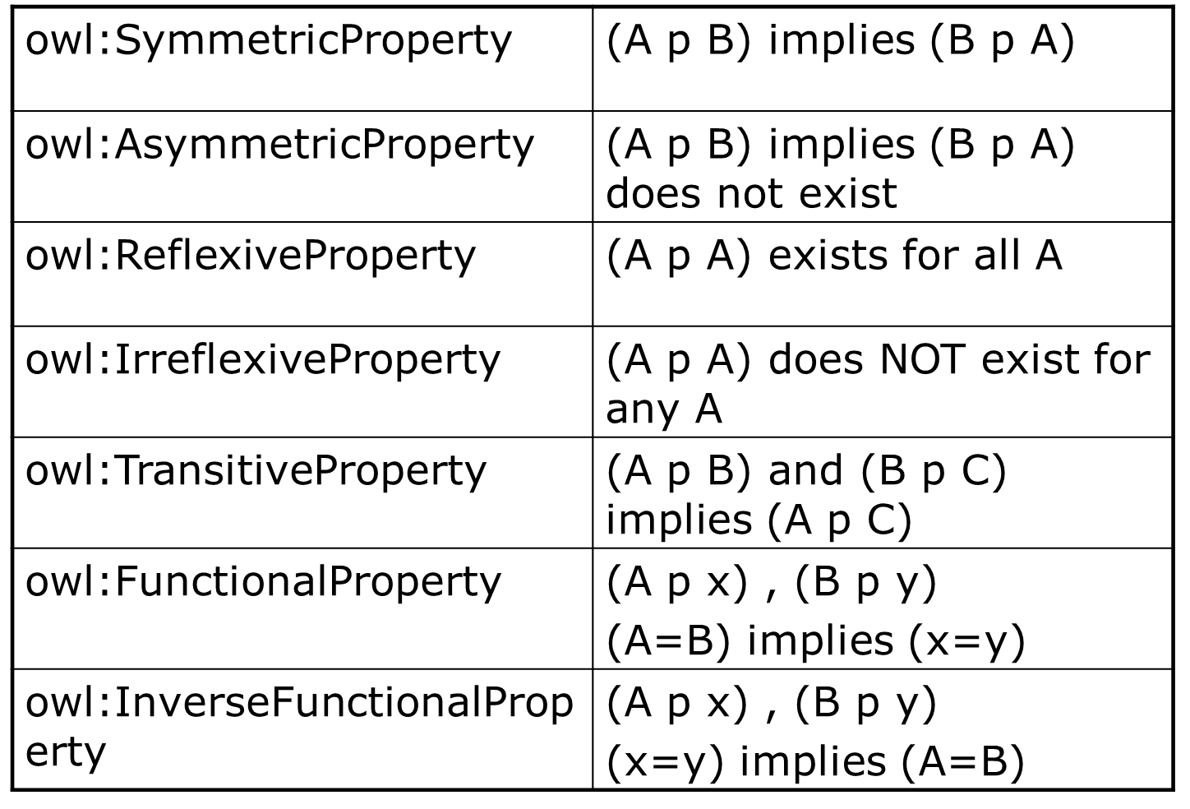

inverse :

//creating inverse property

match (z)<-[r2:rdfs__range]-(x:owl__ObjectProperty{rdfs__label:"hasRating"})-[r1:rdfs__domain]->(y)

merge(i:owl__ObjectProperty{rdfs__label:"inverseOf__hasRating", uri:"http://www.iiitb.ac.in/MovieOntology#inverseOf__hasRating"})

merge(y)<-[:rdfs__range]-(i)-[:rdfs__domain]->(z)

MATCH (n1)-[r1:ns1__hasRating]->(n2)

merge(n1)<-[r2:ns1__inverseOf__hasRating]-(n2)

return n1.uri, n2.uri, r2

Transitive:

\\make loop for hasRating to all properties

match(n1)-[:ns1__hasRating]->(n2)-[:ns1__hasRating]->(n3)

merge(n1)-[r:ns1__hasRating]->(n3)

return n1 as subject,r as predicate,n3 as object

Functional:

//find the functional predicates

match(n:owl__FunctionalProperty)

return n

//for each functional predicate

match (n1)-[:ns1__hasRating]->(n2)

with n1, count(*) as x

where x > 1

return n1.uri

Mayur Suggestions:

1. Transistivity : owl__subClassOf
2. Functional: Display the error if a property designated as functional but have one to many mapping.
3. Inverse: Same as above